***Cute rabbit fur scarf for baby***

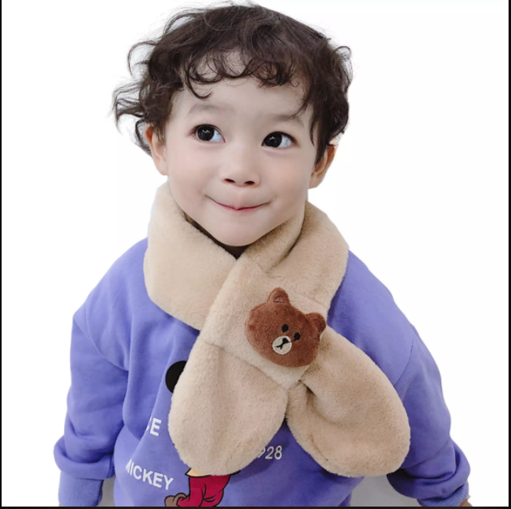

*A lovely scarf is an accessory that both keeps baby warm when winter comes, she can wear it when going out, going to school, during the Christmas season... all suitable and extremely pretty.  
- The scarf is also suitable as a gift, when parents are having a headache choosing a gift for their baby, give them a scarf for their birthday, Christmas gift or learning reward... Definitely our baby would love it.  
- A perfectly designed scarf will make the children extremely lovely and will not feel uncomfortable wearing it because the scarf is very light and the fur is extremely soft. Suitable for all baby's daily wear*